Title: **Number Conversion and Logic Diagrams** Test: 4

Course: Introduction to Automation Unit: Introduction to PLC CLO: 4

Name ____________________________ Date ______________

**Objectives**

1. Student shall calculate the correct number conversion base on a number from a different number base system.
2. Student shall draw the output of an instruction given its input(s).

**Assessment**

Students shall demonstrate a comprehension of the objectives listed above by scoring a minimum of 75% on this Test. Grading shall be based on the answer key.

**Instructions**

Calculate the following number to the new number base system given the value from another number base system.

|  |  |  |  |  |  |  |  |  |  |  |  |  |  |  |  |  |  |  |  |  |  |  |  |  |  |  |  |  |  |  |  |  |  |  |  |  |  |  |  |  |  |  |  |  |  |  |  |  |  |  |  |  |  |  |  |  |  |  |  |  |  |  |  |  |  |  |  |  |  |  |  |  |  |  |  |  |  |  |  |  |  |  |  |  |  |  |  |  |  |  |  |  |  |  |  |  |  |  |  |  |  |  |  |  |  |  |  |  |  |
| --- | --- | --- | --- | --- | --- | --- | --- | --- | --- | --- | --- | --- | --- | --- | --- | --- | --- | --- | --- | --- | --- | --- | --- | --- | --- | --- | --- | --- | --- | --- | --- | --- | --- | --- | --- | --- | --- | --- | --- | --- | --- | --- | --- | --- | --- | --- | --- | --- | --- | --- | --- | --- | --- | --- | --- | --- | --- | --- | --- | --- | --- | --- | --- | --- | --- | --- | --- | --- | --- | --- | --- | --- | --- | --- | --- | --- | --- | --- | --- | --- | --- | --- | --- | --- | --- | --- | --- | --- | --- | --- | --- | --- | --- | --- | --- | --- | --- | --- | --- | --- | --- | --- | --- | --- | --- | --- | --- | --- | --- |
| 1. A16 _______10 | |  |  |  |  |  |  | | --- | --- | --- | --- | --- | --- | | Hexadecimal Truth Table | | | | | | |  |  |  |  |  |  | |  |  |  |  |  |  | |  |  |  |  |  |  | |  |  |  |  |  |  | |  |  |  |  |  |  | |  |  |  |  |  |  | |  |  |  |  |  |  | |  |  |  |  |  |  | |  |  |  |  |  |  | |  |  |  |  |  |  | |  |  |  |  |  |  | |  |  |  |  |  |  | |  |  |  |  |  |  | |  |  |  |  |  |  | |  |  |  |  |  |  | |  |  |  |  |  |  | |  |  |  |  |  |  | |
| 1. 1C16 _______10 |
| 1. 8F16 _______10 |
| 1. 2210 _______16 |
| 1. 3110 _______16 |
| 1. 4210 _______16 |
| 1. 0101 1001 0011 1101 _______16 |
| 1. 1011 0100 1100 0111 _______16 |
| 1. 1111 1010 1111 0110 _______16 |
| 1. 543216 _______________________________________2 | |
| 1. 2FA316 _______________________________________2 | |
| 1. BC4D16 _______________________________________2 | |



1. Word _____
2. Nibble _____
3. Byte _____
4. Bit _____
5. Does this rung have logical continuity? Why or why not? Explain in detail.

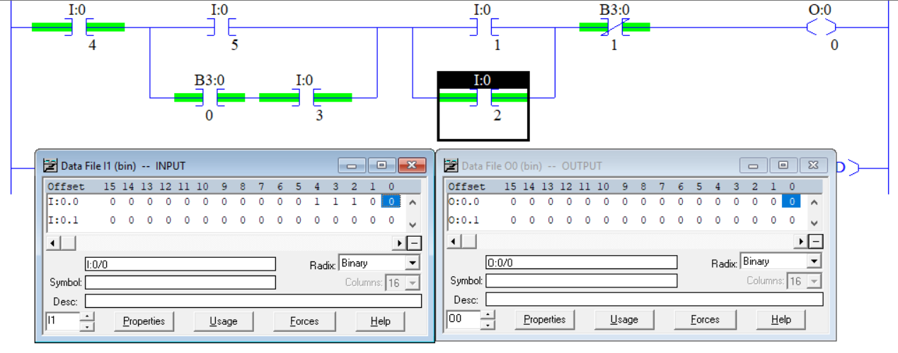

Select the best answer to each multiple-choice question below.

1. An CTU would be used to?
   1. Timing a specific set of contacts
   2. Be a Clock timer unit
   3. Counting up to a certain Preset
   4. Counting down to a certain Preset
2. A CTD would be used to?
   1. Each logical continuity true transition, decrements an integer by one
   2. Subtract two numbers until they equal each other
   3. Counting up to a certain Preset then setting the done bit
   4. Is used to test for a 0 and sets the Accum value
3. Fill in the state of each timer bit (0 or 1).

|  |  |
| --- | --- |
|  | EN _____  TT _____  DN _____ |

1. Fill in the state of each timer bit (0 or 1).

|  |  |
| --- | --- |
|  | EN _____  TT _____  DN _____ |

1. What describes an Integer?
   1. Any natural number
   2. Any number that doesn’t have a fraction.
   3. Is negative or positive
   4. Both b and c
   5. All the above
2. How does a number become negative inside the PLC?
   1. The first bit indicates the sign
   2. The MSB equaling 1
   3. All the bits are 1
   4. None of the above

Draw the output to the following logic diagrams.





1. What is the value of O:0/0?

